Ishita Chandran & Keith Puthoor

CSCI 368 Network Security- Tutorial Project
Week 6

Table of Contents
Contribution List 3
Company Profile 4
Business Units of CloudCafe: 4
Business Requirements and Risk Assessment 5
Criticality of Each Department 5
Possible Threats 6
Feared Events and Downtime Tolerance 6
Budget Allocation 7
Hardware Costs 7
Software Costs 7
Operational Costs 8
1. Network Segmentation and IP Addressing 9
2. Detailed ACL Rules Applied 9
3. Cisco Packet Tracer Configuration: 10
4. Packet Tracer Testing Results 12
Test 1: Successful Connectivity (Permitted Traffic) 12
Test 2: Failed Connectivity (Denied Traffic) 12
1. Packet Tracer Screenshots 13
2. Best Email Security Practices - Report Hardening 14
A. Email Authentication Protocols 14
B. Network Security & Access Control 14
C. User Authentication & Account Security 14
Securing Web Communication 15
1. Which Certificate Authority Should Be Used? – Report Hardening 15
2. Self-Signed VS CA-issued Certificates 16
3. Certificate Duration 16
4. Certificate Renewal 16
5. Private Key Security 17
• Software-Based Security (Standard) 17
• Hardware-Based Security (High-Assurance) 17
6. Steps That Should Be Taken in Case the Private Key / Certificate Has Been Compromised 17
New Branch Office 18
1. New Branch Office Design & Purpose 18
Purpose & Location: 18
Network Design: 18
2. The Necessity of IPsec for Secure Connection 18
3. Step-by-Step VPN Configuration 19
Network Details: 19
Setting up WAN 20
Setting up VPN 23
Resource Adjustments 25
Firewall Configuration 25
Wireless Network Implementation 27
1. Internal Staff Wireless Network (WPA2-Enterprise) 27
Network Integration and Topology 27
Configuration Summary 28
2. Customer Guest Wireless Network (WPA2-Personal) 28
Network Integration and Topology 28
Configuration Summary 29

Contribution List
Team Members:
Ishita Chandran 8479513 – Team Leader
Keith Puthoor 7761582

 | Submissions | Packet Tracer | Doccument
1 | Week 2 | Ishita | Ishita
2 | Week 3 | Ishita | Ishita
3 | Week 4 | Keith | Ishita
4 | Week 5 | Ishita | Keith
5 | Week 6 | Keith | Ishita
6 | Week 8 | Ishita | Keith
7 | Week 9 | Keith | Keith + Ishita

Company Profile
CloudCafe is a private cloud kitchen café company that operates as a delivery only café and a digital platform to connect the café to its customers and the staff of the company. It provides a reliable platform for online orders, inventory management, delivery coordination and secure payments.

Business Units of CloudCafe:
 | Units | Description | Criticality
1 | Kitchen Operations | Prepares customer’s orders. | High.  Orders cannot be fulfilled without the kitchen operations.
2 | IT Department | Manages servers, networks, website, order platform, cybersecurity, and data integrity. | High.  Central system for order processing, payments, and security.
3 | Management Department | Handles HR, payroll, inventory tracking and general management. | Medium.  Supports operations but not directly involved with order processing.
4 | Delivery & Logistics Department | Coordinates delivery staff and order tracking. | Medium to High.  Delays or improper transportation of order can affect the order and customer satisfaction.
5 | Marketing Department | Handles promotions and customer engagement. | Medium.  Supports the business’ growth, does not affect order fulfilment.
6 | Customer Service | Handling customer inquiries, complains and order support. | Medium.  Improves customer experience , may affect business’ growth due to bad customer care.

Business Requirements and Risk Assessment

Criticality of Each Department
 | Department | Criticality | Impact if Shut Down
1 | Kitchen Operations | High | Orders cannot be prepared -> Direct revenue loss
2 | IT Department | High | Orders and payments cannot be processed -> Direct revenue loss
3 | Management Department | Medium | Inventory tracking and HR management affected -> Low impact on orders
4 | Delivery & Logistics | Medium –  High | Orders delayed -> Customer dissatisfaction
5 | Marketing Department | Medium | Promotions delayed -> Low effect on growth
6 | Customer Service | Medium | Customer complaints unresolved -> Low effect on reputation

Possible Threats
- Data breaches exposing customer information.
- Malware or ransomware attacks on servers.
- Network outages affecting order system.
- Payment fraud
- Phishing attacks

Feared Events and Downtime Tolerance
 | Feared Event | Acceptable Downtime | Impact
1 | Order Platform Failure | <1 hour | Cannot process online orders, loosing revenue.
2 | Kitchen Management System Down | <2 hours | Inventory and preparations are disrupted.
3 | Data Breach | <4 hours | Customer data being compromised and causing reputational damage.
4 | Delivery Tracking Failure | 1 day | Delays in delivery, revenue loss due to nature of the products needing to be delivered within an hour.
5 | Management System Failure | <2 hours | HR, payroll and inventory cannot be accessed.
6 | Marketing System Failure | 1 day | Any promotional campaigns will be delayed, low impact
7 | Customer Service System Failure | 4 hours | Customer complaints resolution can take time, making customers angry and loosing customers.

Budget Allocation

Hardware Costs
 | Item | Estimated Cost (AED) | Explanation
1 | Firewalls | 50,000 | Protect servers and the network.
2 | Networking Equipment | 40,000 | Routers, switches and cabling for all departments.
3 | Backup Hardware | 30,000 | UPS(Uninterrupted power supply), external storage and redundancy.
Total ≈ 120,000 AED

Software Costs
 | Item | Estimated Cost (AED) | Explanation
1 | Antivirus & EDR | 50,000 | Protect kitchen and IT systems from malware
2 | Encryption & Backup Tools | 50,000 | Encrypt sensitive customer/payment data and backup files
3 | Monitoring & Access Control | 20,000 | Logs and controls access between departments
Total ≈ 120,000 AED

Operational Costs
 | Item | Estimated Cost (AED) | Explanation
1 | Staff Security Training | 25,000 | Awareness of phishing, password management, and safe system usage.
2 | Maintenance & Patch Management | 25,000 | Regular updates to servers, POS, and networking systems.
3 | Incident Response & Recovery | 15,000 | Backup response services and post-incident analysis,
Total ≈ 65,000 AED
Sum Total ≈ 305,000 AED

1. Network Segmentation and IP Addressing
The network structure divides the company into separate security zones. The IT Department (192.168.20.0/24) includes the two assigned IT staff members who handle network diagnostics and management.
CloudCafe Departments | Zone/Role | IP Subnet/VLAN | Specific Hosts
Kitchen Operations | Internal/Operations | 192.168.10.0/24 | KO Staff 1:  192.168.10.2  KO Staff 2:  192.168.10.3
IT Department | Management | 192.168.20.0/24 | IT Staff 1: 192.168.20.2  IT Staff 2: 192.168.20.3
Management/Admin Dept | Internal | 192.168.30.0/24 | Admin Staff 1:  192.168.30.2  Admin Staff 2:  192.168.30.3
Delivery & Logistics | Internal/Operations | 192.168.40.0/24 | Delivery Staff 1:  192.168.40.2  Delivery Staff 2:  192.168.40.3
Marketing Department | Internal | 192.168.50.0/24 | Marketing Dept. 1:  192.168.50.2  Marketing Dept. 2:  192.168.50.3
Customer Care | Internal | 192.168.60.0/24 | Customer Care 1:  192.168.60.2  Customer Care 2:  192.168.60.3
External/Web Server | External | 192.168.70.0/24 | DNS Server:  192.168.70.2  Website Server:  192.168.70.3

2. Detailed ACL Rules Applied
An Extended Numbered ACL (100) is configured on the router to control traffic flow. The security policy is highly granular, limiting ICMP (Ping) traffic for network diagnostics to only the two specific IT staff members, thus enforcing a strict access control policy.
The router is configured with an Extended Numbered ACL (100) to control flow of traffic. The security policy is very strict, allowing ICMP (Ping) traffic for network diagnostics only to the two specifically identified IT staff members, ensuring a strict access control policy.

Rule No. | Action | Protocol | Source Host/Subnet | Wildcard Mask (Configuration) | Destination | Security Goal
10 | Permit | ICMP | IT Staff 1 (192.168.20.2) | 255.255.255.0 | Any | Allow diagnostics for IT Staff 1.
20 | Permit | ICMP | IT Staff 2 (192.168.20.3) | 255.255.255.0 | Any | Allow diagnostics for IT Staff 2.
30 | Deny | ICMP | Any | Any | Any | Explicitly deny all other ICMP traffic not coming from the two permitted hosts.
Implicit | Deny | All Other IP | Any | Any | Any | The implicit “deny ip any any” prevents all other protocols (TCP, UDP, etc.) from being explicitly allowed, creating a highly restricted network.

3. Cisco Packet Tracer Configuration:
The following commands were used to define and apply the security policy on the main router.
access-list 100 permit icmp 192.168.20.2 0.0.0.0 any
access-list 100 permit icmp 192.168.20.3 0.0.0.0 any
access-list 100 deny icmp 192.168.10.0 0.0.0.255 any
access-list 100 permit ip any any
! VLAN 20 (Admin)
interface fa0/0.30
ip access-group 100 in
ip access-group 100 out
exit

! VLAN 10 (Kitchen)
interface fa0/0.10
ip access-group 100 out
exit
! VLAN 30 (Management/Admin)
interface fa0/0.30
ip access-group 100 out
exit

! VLAN 40 (Delivery)
interface fa0/0.40
ip access-group 100 out
exit

! VLAN 50 (Marketing)
interface fa0/0.50
ip access-group 100 out
exit

! VLAN 60 (Customer Care)
interface fa0/0.60
ip access-group 100 out
exit

! VLAN 70 (Web Server)
interface fa0/0.70
exit

4. Packet Tracer Testing Results
Testing was performed to ensure that the ACL properly filters ICMP traffic according to the security policy.

Test 1: Successful Connectivity (Permitted Traffic)
- Test: Ping from any IT Staff’s PC ex. (192.168.20.2) to any Kitchen Operations PC ex. (192.168.10.2).
- Result: Ping is Successful (Traffic is allowed by Rule 10, because the source is one of the permitted IT hosts).
- Verification: The IT staff member is successfully allowed to test connectivity across the network.

Test 2: Failed Connectivity (Denied Traffic)
- Test: Ping from any Kitchen Operations PC ex. (192.168.10.3) to any Delivery & Logistics PC ex. (192.168.40.2).
- Result: Ping is Failed/Destination Host Unreachable (Traffic is blocked by Rule 30, because it does not originate from the two allowed IT staff/hosts).
- Verification: All ICMP traffic from unauthorized and from non-management zones is denied, making sure it segments and restricts unauthorized testing.

2. Best Email Security Practices - Report Hardening

1. Packet Tracer Screenshots
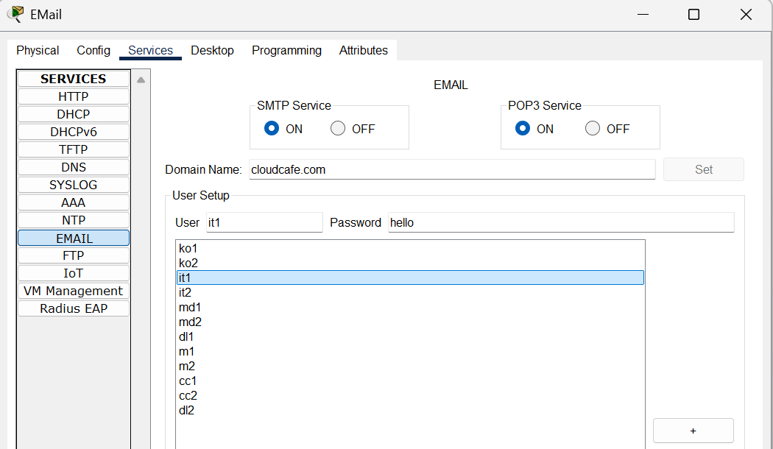
Email Server Config
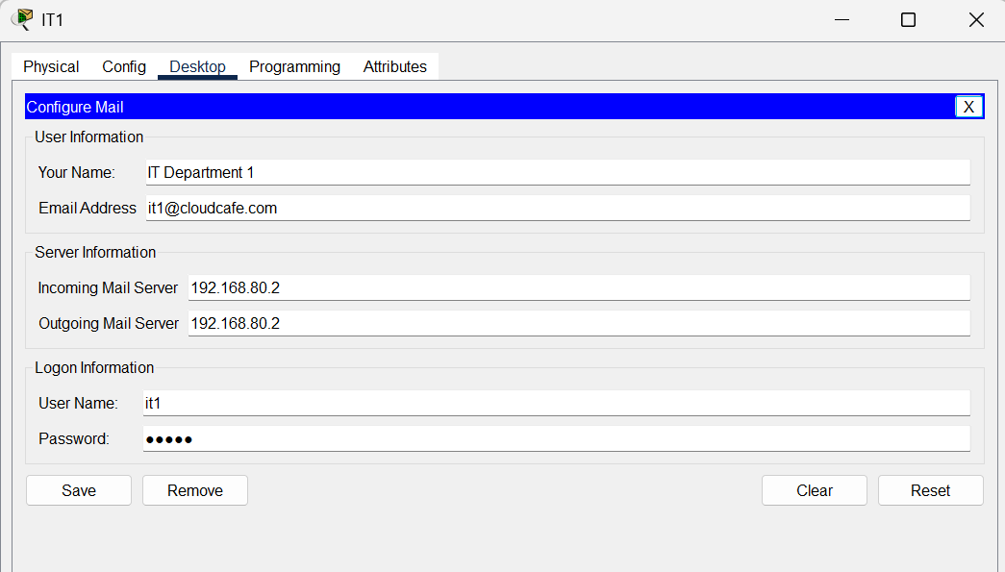
Example Config (IT1)

A. Email Authentication Protocols
Implement SPF, DKIM, and DMARC together to prevent email spoofing and phishing.
- SPF (Sender Policy Framework): Create a DNS record that lists all IP addresses authorized to send email for your domain.
- DKIM (DomainKeys Identified Mail): Add a cryptographic digital signature to outgoing emails to verify the message has not been altered.
- DMARC (Domain-based Message Authentication, Reporting, and Conformance): Unifies SPF and DKIM, tells receiving servers how to handle failed emails (quarantine or reject), and provides security reports.
  - How to Implement DMARC: Roll out DMARC in phases: start with a monitoring policy (p=none), then move to p=quarantine, and finally p=reject.

B. Network Security & Access Control
Harden the server's network perimeter to minimize the attack surface.
- Firewall Policy: Use a "deny by default" approach. Only allow traffic on necessary, secure ports.
  - ALLOW: SMTPS (465), Secure Submission (587), IMAPS (993), POP3S (995).
  - BLOCK: Unencrypted ports like IMAP (143) and POP3 (110).
- Encryption in Transit: Enforce modern TLS 1.2 and TLS 1.3 for all email connections to protect data from eavesdropping.
- Secure Admin Access: Administrative ports (SSH, RDP) must never be exposed to the public internet. Access should be restricted to a VPN or a secure jump server.
- Prevent Open Relays: Configure the server to require authentication for sending outbound email to prevent it from being used for spam.

C. User Authentication & Account Security
Protect user accounts, which are a primary target for attackers.
- Password Policy (NIST-aligned National Institute of Standards and Technology):
  - Enforce a 14+ character minimum length; encourage passphrases.
  - Eliminate mandatory password expiration and complex character requirements (e.g., !@#$).
  - Block common and previously breached passwords.
- Multi-Factor Authentication (MFA):
  - MFA is mandatory for all accounts.
  - Prioritize secure methods like authenticator apps and security keys over SMS, which is vulnerable to SIM swapping.
- Automated Defenses:
  - Account Lockout: Temporarily lock accounts after 10-20 failed login attempts to stop brute-force attacks.
  - Rate Limiting: Limit login attempts from a single IP address to prevent password spraying attacks.

Securing Web Communication
The Web Server is assigned the static IP address 192.168.70.3 and hosts the website accessible via the domain name cloudcafe.com. The DNS Server, located at 192.168.70.2, resolves the domain name to the server's IP. To secure the server, extended access-list 102 is configured and applied to the router's interface in the inbound direction. This ACL policy strictly controls access: it permits TCP traffic from any source (any) to the server (host 192.168.70.3) only on port 443 (HTTPS). All other traffic is explicitly blocked by the final deny ip any any rule, ensuring that the Web Server is only accessible for its intended secure web services.

1. Which Certificate Authority Should Be Used? – Report Hardening
For most small businesses / self-hosted webserver Lets Encrypt is more than enough as it is free and the certificates can be renewable easily with a client like Certbot
For big businesses that need they their verified names in the certificate so that customers can trust the website. And they provide warranty and dedicated technical support.
Eg. DigiCert or Sectigo

2. Self-Signed VS CA-issued Certificates
Certificate Type | How It Works | Best Use Case | Trust Level (Browsers)
Self-Signed | You create and sign the certificate yourself. It is not verified by a trusted third party. | Only for internal use for test servers or internal tools where all users are within your organization and can be instructed to trust the certificate. | None. Public browsers will show a severe security warning driving visitors away.
CA-Issued (Let's Encrypt) | A free, automated CA that provides Domain Validated (DV) certificates. It verifies you control the domain, but not your organization's identity. | Public-facing websites, blogs, and any service needing basic encryption and browser trust. It provides the same encryption level as paid certificates. | High. Trusted by 99.9% of all modern browsers. Users see the "padlock" icon.
CA-Issued (Paid CAs) | Commercial CAs like DigiCert or Sectigo provide DV, Organization Validated (OV), and Extended Validation (EV) certificates. OV/EV certs require vetting your legal business identity. | E-commerce, finance, or enterprise sites. The OV/EV validation provides a higher level of user trust by verifying your company's identity, not just its domain. They also typically include customer support and warranties. | Highest. The organization's verified name is visible in the certificate details, providing maximum assurance to users.

3. Certificate Duration
2-3 years the certificate had to be renewed but as of 2025 the maximum duration for all public SSL/TLS certificates is 398 days (approximately 13 months).

4. Certificate Renewal
- Let's Encrypt (Automated): Designed for automation. It uses the ACME (Automated Certificate Management Environment) protocol. A client like Certbot runs on your server, automatically renewing and installing the certificate every 60-90 days without human intervention.
- Paid CAs (Manual/Automated): The traditional process is manual: you receive an email, purchase the renewal, generate a new Certificate Signing Request (CSR), and manually install the new certificate. However, most major CAs like DigiCert now also support the ACME protocol, allowing you to automate their paid certs in the same way as Let's Encrypt.

5. Private Key Security

Software-Based Security (Standard)
The key should be generated on the server and never transferred. Its file permissions must be locked down.

Hardware-Based Security (High-Assurance)
Hardware Security Module (HSM): For maximum security (e.g., banking, high-compliance), the private key is generated and stored inside a dedicated, tamper-resistant hardware device (HSM).

6. Steps That Should Be Taken in Case the Private Key / Certificate Has Been Compromised
- Invalidate the certificate by contacting the CA or by using the CA dashboard and revoking the certificate. This adds the certificate's serial number to a global Certificate Revocation List (CRL).
- And generating a new Public and private key pair to create the new certificate.
- Request a new certificate from the CA.
- Install the new certificate.

New Branch Office

1. New Branch Office Design & Purpose

Purpose & Location:
To support the expansion of CloudCafe, a new branch has been established in Abu Dhabi. This branch operates as a restaurant that sells confectionery items supplied by the main Dubai (HQ) branch. Secure and reliable communication is essential for inventory, sales, and logistics coordination.

Network Design:
The Abu Dhabi branch network is segmented into two subnets to separate traffic for its primary functions:
- Delivery Subnet: 192.168.100.0/24 (Contains workstations for managing logistics and deliveries).
- Customer Care Subnet: 192.168.110.0/24 (Contains workstations for customer orders and support).

2. The Necessity of IPsec for Secure Connection
To connect the new Abu Dhabi branch (R3) to the Dubai HQ (R1), all traffic must pass through an intermediary "pass-through" router (R2) that represents the public internet. This is an untrusted network, making an IPsec VPN essential.
- Confidentiality: IPsec encrypts all data packets (e.g., using AES or 3DES) exchanged between R1 and R3. This ensures that if an attacker intercepts the traffic, they cannot read sensitive company data.
- Integrity: The (ESP) protocol uses a hashing algorithm (e.g., SHA) to verify that data has not been altered in transit.
- Authentication: R1 and R3 authenticate each other using a Pre-Shared Key (vpnpa55) to prove their identities before building the secure tunnel.

3. Step-by-Step VPN Configuration
R1 is the HQ (Dubai) router, R3 is the new branch (Abu Dhabi) router, and R2 is the pass-through router.

Network Details:
Device | Role | Interface | IP Address / Subnet
R1 (HQ) | HQ Router | LAN 1 | Fa0/1.10 (192.168.20.0/24)
 |  | Lan 2 | Fa0/1.20 (192.168.20.0/24)
 |  | … | …
 |  | Lan 8 | Fa0/1.80 (192.168.80.0/24)
 |  | WAN | S0/0/0 (Peer IP: 10.1.1.2)
R2 | Pass-through | WAN 1 | S0/0/0 (IP: 10.1.1.1)
 |  | WAN 2 | S0/0/1 (IP: 10.2.2.1)
R3 (Branch) | Abu Dhabi Router | WAN | S0/0/1 (Peer IP: 10.2.2.2)
 |  | LAN 1 | Fa0/0.100 (192.168.100.0/24 (Delivery))
 |  | LAN 2 | Fa0/0.110 (192.168.110.0/24 (Customer Care))

Setting up WAN
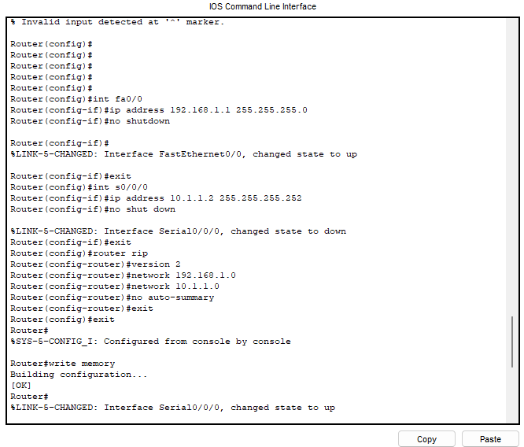
Router 1

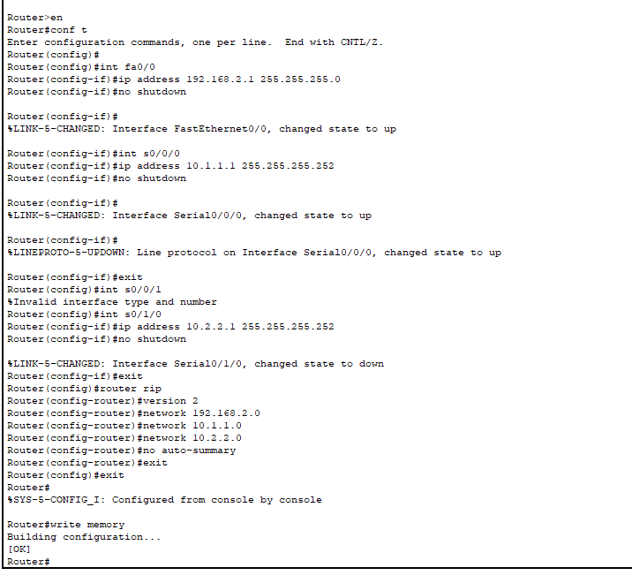
Router 2

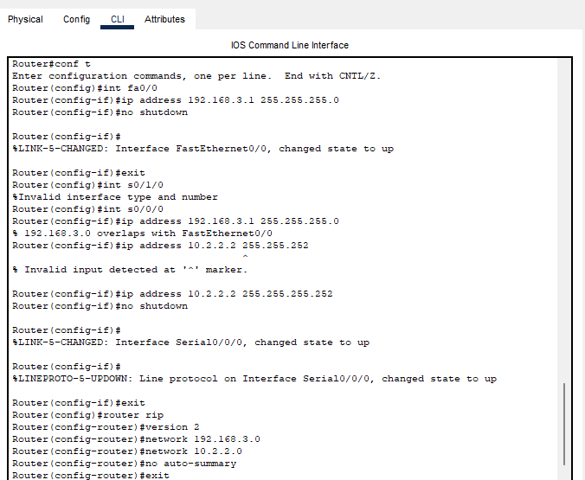
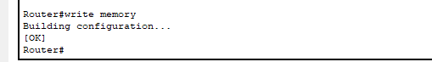
Router 3
Setting up VPN
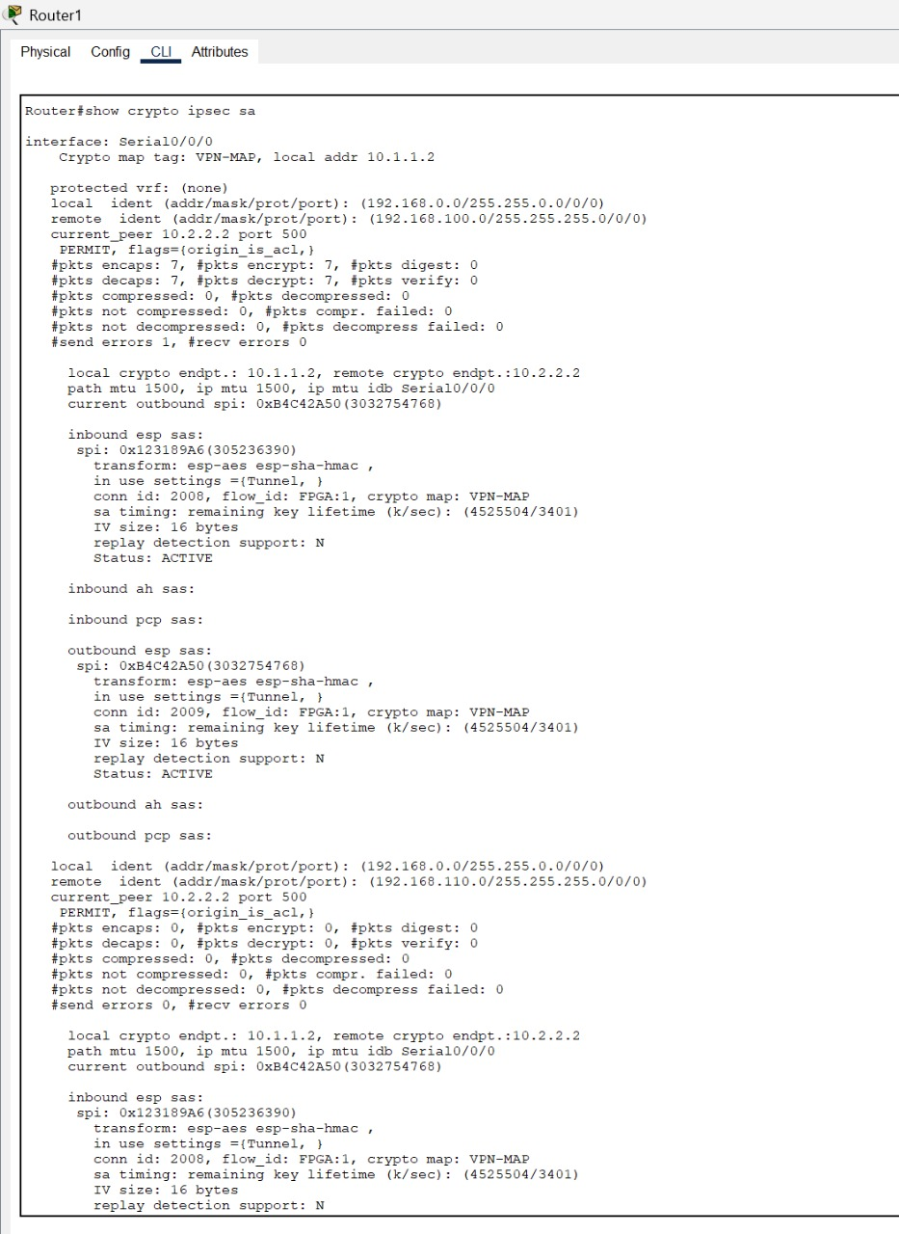
Router 1
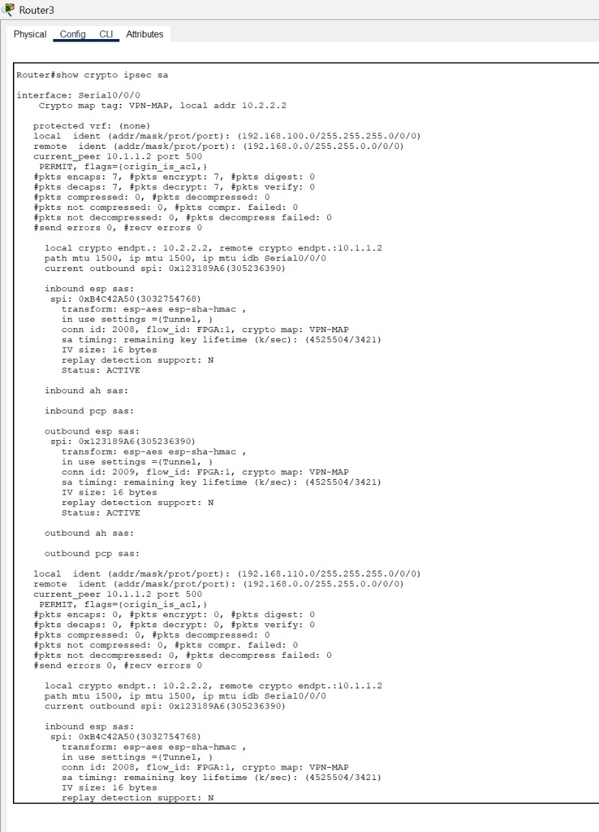
Router 3
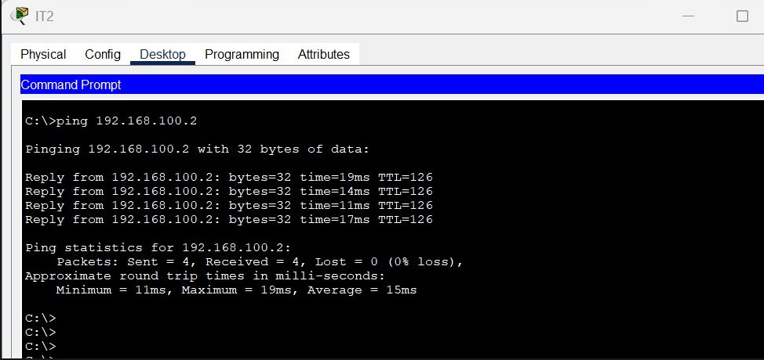
Ping from IT2 (192.168.20.3) to Delivery1 (192.168.100.2)

Resource Adjustments
No changes have been made, we have already used the least number of routers and switches as possible through our weekly submissions. No IP has also been changed.
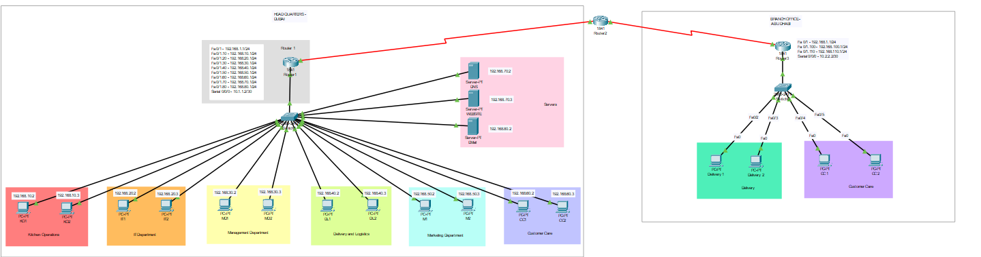

Firewall Configuration
On the HQ router, a Zone-Based Policy Firewall (ZPF) was implemented. The following three security zones were configured for the email sever:
IN-ZONE → the internal LAN devices
OUT-ZONE → The external/WAN network
An extended access list was configured to define what internal traffic was. A class-map was defined to match the internal traffic as defined by the ACL.A policy-map (IN-2-OUT-PMAP) was configured to apply stateful inspection. A zone-pair (IN-2-OUT-ZPAIR) was configured to join the two zones together and apply the firewall policy. This allows communication from the internal hosts to external resources, and any traffic from the external zone to the internal zone is dropped by default unless specified otherwise.

Wireless Network Implementation
This section details the design, configuration, and security implementation of the secure wireless networks for CloudCafe, covering the internal staff network (WPA2-Enterprise) and the customer guest network (WPA2-Personal).

1. Internal Staff Wireless Network (WPA2-Enterprise)
The internal wireless network is designed to provide secure access for HQ employee’s devices using individual credentials, adhering to enterprise security best practices. WPA2-Enterprise is mandatory for highly secure environments as it provides per-user authentication, enabling specific access rights and auditing capabilities.

Network Integration and Topology
The staff wireless network is segmented using a dedicated VLAN to isolate wireless traffic from the main departmental subnets, enhancing security and preventing lateral movement.
- Location: HQ (Dubai) Network, connected to Router 1.
- Physical Connection: The Wireless Router (WRT300N) is connected to switch 1 on port GigabitEthernet0/1.
- Logical Segmentation: The network is placed on VLAN 200 (Wireless).
- WLAN Subnet: 192.168.200.0/24
- Wireless Router (AP) IP: 192.168.200.1 (Acts as the gateway for wireless clients).
- Authentication Server (RADIUS): Located at 192.168.200.3 (within the WLAN subnet).

Configuration Summary
Setting | Value | Security Justification
SSID | SecureWiFi (or similar) | Identifies the official staff network.
Security Mode | WPA2 Enterprise | Provides strong, per-user authentication using a RADIUS server (802.1X), which is the recommended enterprise standard for auditing and access control.
Encryption | AES | Provides robust, modern encryption for all data traffic, meeting current security standards.
RADIUS Server IP | 192.168.200.3 | The address of the central server verifying individual staff usernames and passwords.
User Access | IT Department and Management Department staff | Access is granted based on individual, centralized credentials verified by the RADIUS server.

2. Customer Guest Wireless Network (WPA2-Personal)
A separate wireless network is provided for customers visiting the shop. This network uses WPA2-PSK for simple access but is strictly isolated from all corporate assets.

Network Integration and Topology
- Location: Abu Dhabi Branch Network, connected to Router 3.
- Wireless Router IP (Gateway): 192.168.3.2
- Purpose: To provide complimentary internet access for customer laptops and smartphones.
- IP Assignment: Customer devices receive IP addresses automatically via DHCP.

Configuration Summary
Setting | Value | Security Justification
SSID | CloudCafe - Customer Free WIFI | Clearly identifies the network as a non-staff, guest service.
Security Mode | WPA2-Personal (PSK) | Simple for public use, relying on a single pre-shared key for access control.
Passphrase | cloudcafe | An easily shared, standard key for guests.
Encryption | AES | Maintains a basic level of encryption for customer data.

